**Team Project 2 Proposal**

*The Foo Bars*

1. **A brief articulation of your chosen topic and rationale**
   * Create visualizations showing different statistics by NBA player. There are many basketball websites with a lot of player data and stats, but not presented in visualizations.
2. **A link to your dataset(s) and a screenshot of the metadata if it exists**
   * <https://www.basketball-reference.com/>
   * <https://stats.nba.com/players/clutch-scoring/?sort=GP&dir=-1>
   * More to be determined
3. **3-4 screenshots of relevant "inspiring" visualizations that frame your creative fodder**

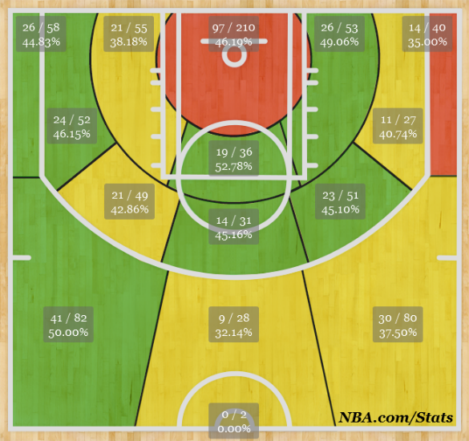

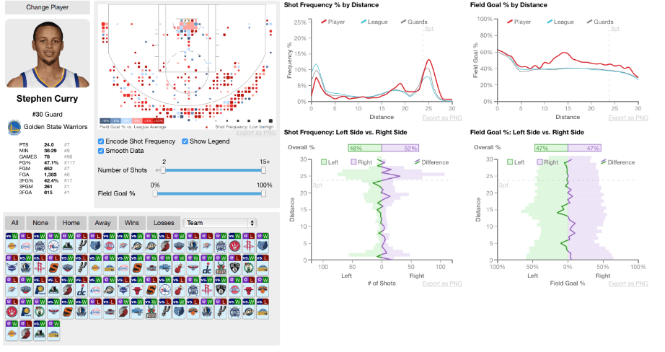

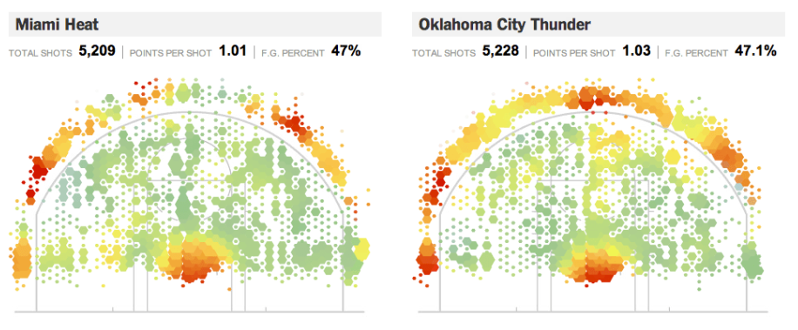

1. **A sketch of the final design**
   * Heat Map Basketball Court visualization for shot percentage by zones (i.e. Paint, Mid-Range, Long-Range, etc.)

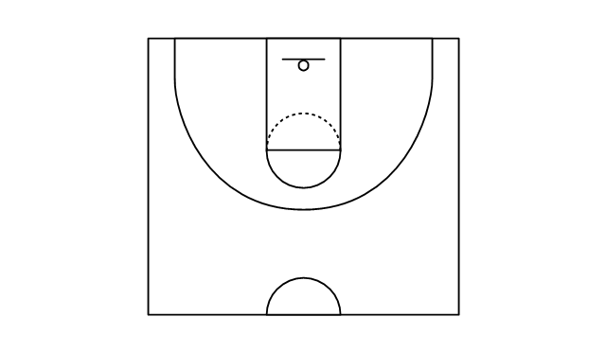

* + Line Chart showing Field Goal percentages by quarter
  + Scatter Plot of Player Statistics where user can change the axes for different stats such as True Shooting %, Player Efficiency Rating, etc.

1. **A link to the primary GitHub repository you'll be housing your work in**
   * <https://github.com/mynameisjohnn/the_foo_bars.git>